* Start with a video demo of NICTA’s National Map to display the goal of our project.
  + Possibly show how data doesn’t work on map in its present form
  + 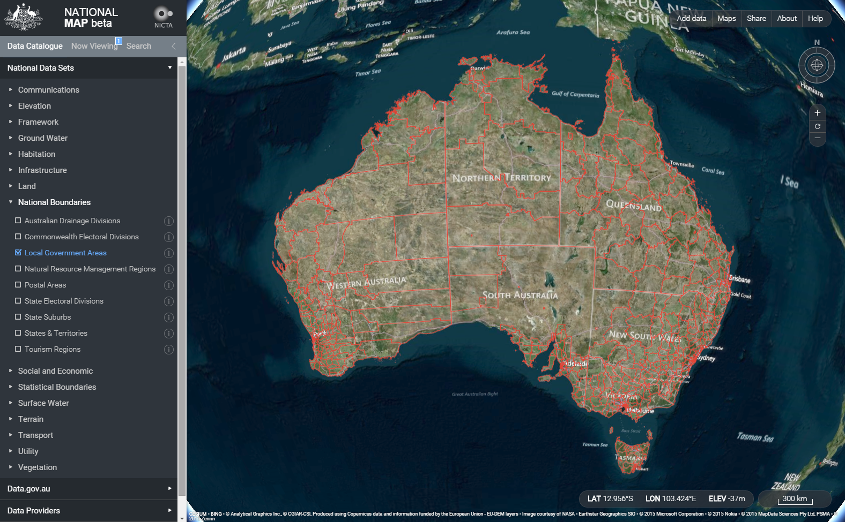
* Explain that the map features capability for anyone to apply their own data to it
  + The map supports many formats, but those formats must be used very specifically
  + Our goal is to develop a way to format the data to be used on the map
    - By utilizing tools such as QGIS and PostGreSQL
* Explain the problem with the non-aggregated data.
  + The data is split among multiple files and is not aggregated at all
* Talk about our decision to use SQL to handle the aggregation process.
  + Created a database for non-aggregated data
  + Added tables representing each data file to the database
* Some data is aggregated nicely but some is not
  + Explain script (for now in SQL) for aggregating data and explain the process.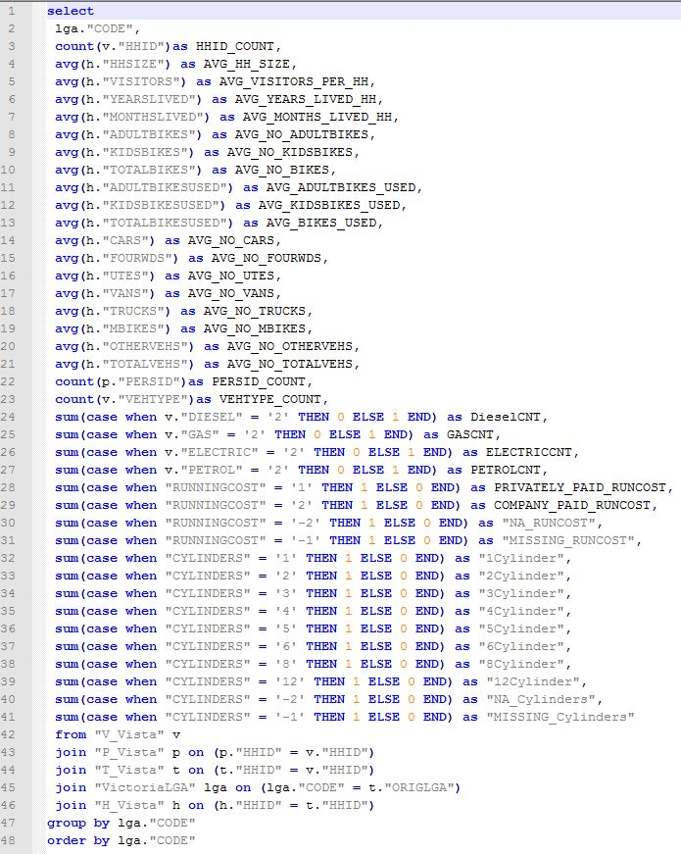
  + 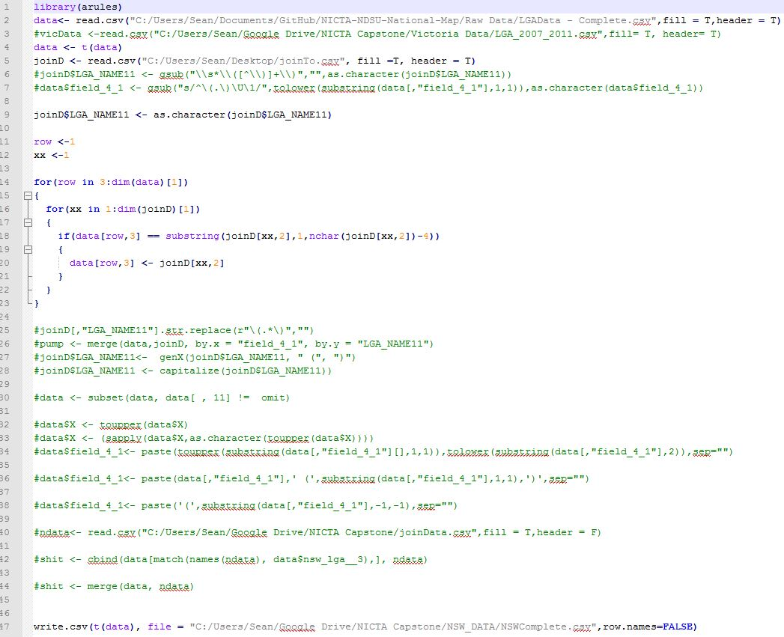Explain script (for now in R) for joining aggregated data to geographic data so it works on the map
* Now we have all the data we need, but it is very large and contains multiple surveys. So we have a script to break down the data into individual survey topic areas so the map can display them
* Summarize conversion process using infographics such as the one below

CSV with Surveys 1, 2, 3, and 4

Survey 1 CSV

Survey 2 CSV

Survey 3 CSV

Survey 4 CSV

* Show video result by dragging and dropping data onto the map